Screenshots of the Front-End (still under development)
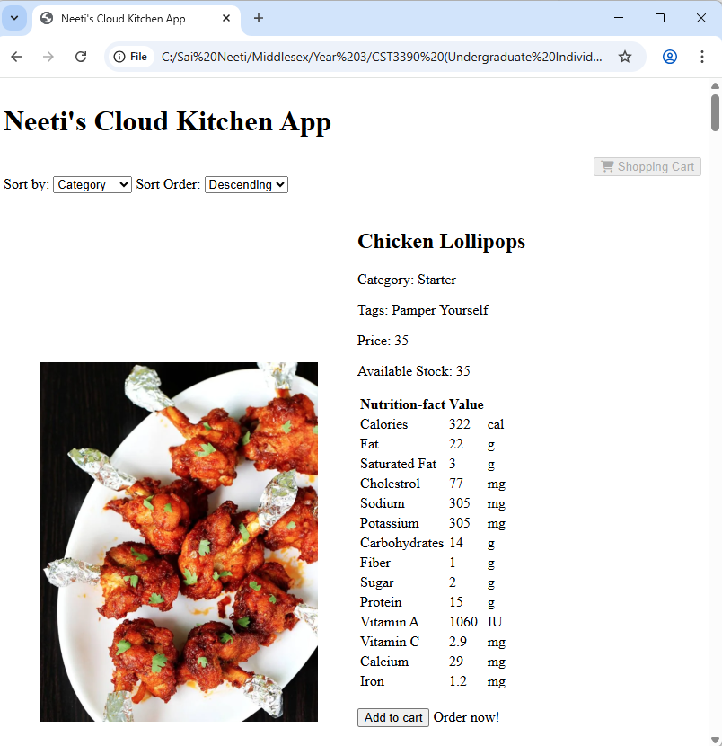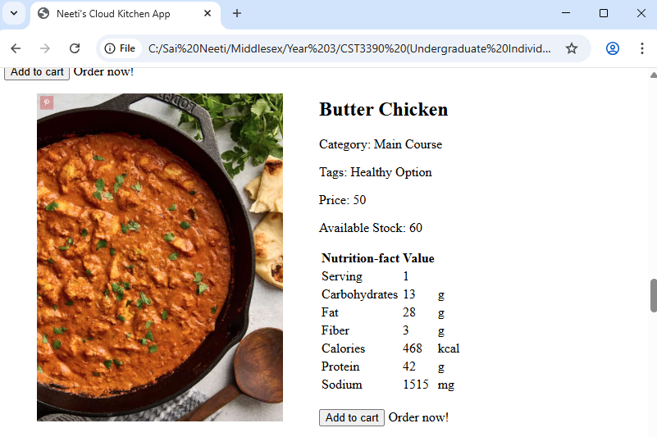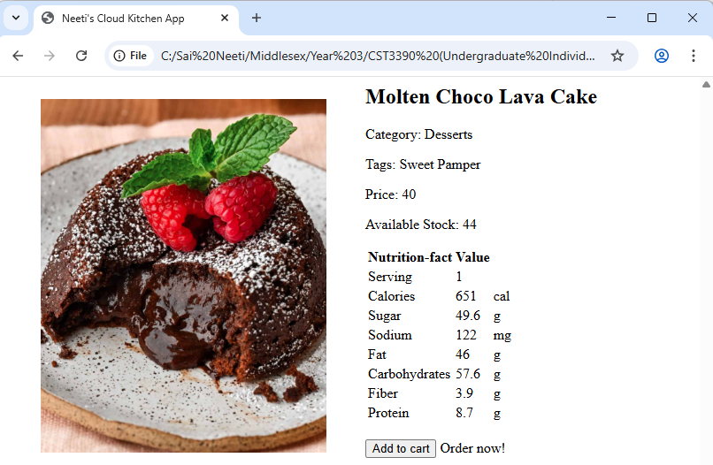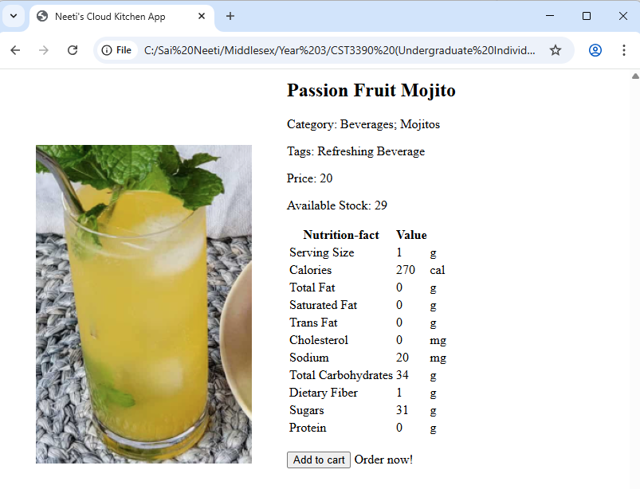
When the selection is complete, click on “Shopping Cart” button.

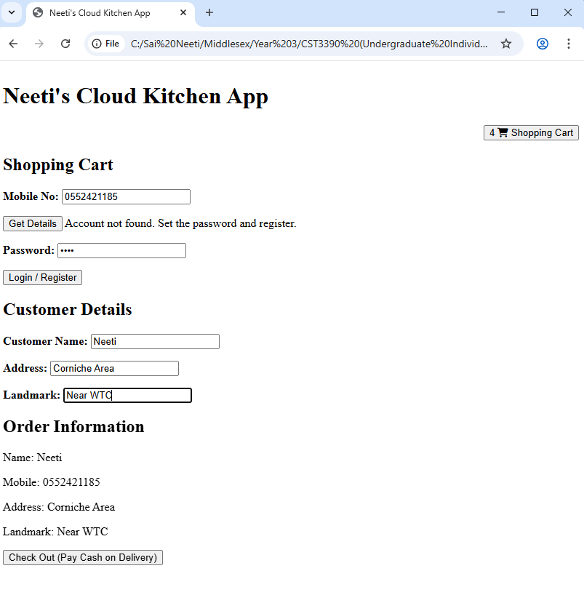
User logs in with the mobile number.
- If the account is not found, the user can enter a password and enter customer details.
- If account is found, the customer details are fetched from the MongoDB Database through the Back-End Web Service and displayed to the user.
When user clicks on Checkout, the Order details and Customer details are stored in the database and the stock available for each dish selected is updated.

Screenshots of the Back-End
The Back-End has been developed in Node.js and Express.js. It has been tested using Postman.
Following is a screenshot of the requests created in Postman to test the REST API.
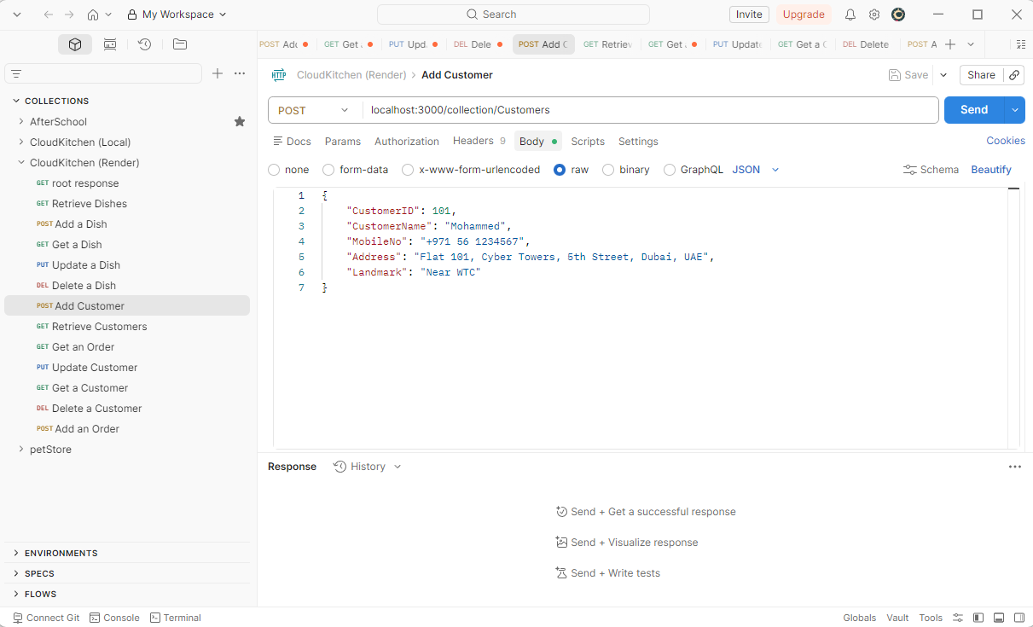

Following is a screenshot of the MongoDB Database, viewed through MongoDB Compass.
